**AWS-Create VPC**

**Create AWS VPC (Virtual Private Cloud)**

An AWS VPC is a virtual private cloud in the AWS Cloud where you can provision and run different AWS resources (e.g. ECS container instances, Lambda functions, RDS database instances etc).

Follow these steps to create your VPC:

1. Sign into the AWS Management Console at <https://aws.amazon.com/console/>. Make sure your Region is N. Virginia.
2. Go to the **VPC Service** section and select **Your VPCs** in the left menu.
3. Click **Create VPC** and enter the following details under VPC settings:
   * Resource to create – **VPC and more**
   * Check **Auto-generate** and type in ***yourlastname-vpc***. This field say “project” by default
   * IPv4 CIDR block – Should be set to ***10.0.0.0/16*** .
   * IPv6 CIDR block - No IPv6 CIDR block.
   * Tenancy - **Default**.
   * Number of AZs– **1**
   * Number of public subnets– **1**
   * Number of private subnets – **1**
   * NAT gateways – **None**
   * VPC endpoints – **None**
   * You should now be able to see your Network layout on the right.
4. Click **Create VPC**.
5. Click **View VPC** to see your newly create VPC

**Testing**

To test this setup, you will launch 2 EC2 Instances, one in the public subnet and one in the private subnet. You will be able to access the public server from the Internet but not the private server. However, you should be able to ping the private IP address from the public server.

**Creating the EC2 Instances**

1. Go to **EC2>Instances** and click **Launch Instances**. For the Public subnet server, name it ***yourlastname-pubsvr*** and for the Private subnet server, name it ***yourlastname-privsvr.***
2. For both Instances, choose the Linux Amazon 2 AMI and t2.micro (free-tier)
3. If private keys are needed, use the private key from your previous labs.
4. On the **Network settings**, click the Edit button. Select ***yourlastname-vpc*** under *VPC* and for the public server, choose the *public subnet* and private server, choose *private subnet*. **Enable** the *Auto-assign public IP* for both.  
   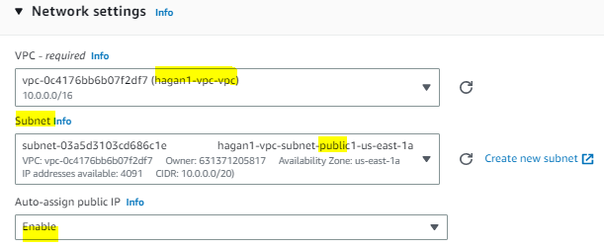
5. For Security Groups, choose **Create Security group** and name it ***yourlastname-vpc-sg***. Set Inbound rules for ssh and ICMP. (For the Private Server, choose **Select existing security group** and select the ***yourlastname-vpc-sg***).
6. Launch instances. While the instances are waiting to pass the Health check, click on the settings icon under the Launch Instance dropdown on the right.
7. Enable **Private IP address**. Disable **IPv6 IPs**, **Elastic IP**, **Public IPv4 DNS**, and **Instance type**. This will eliminate certain columns for display purposes.
8. Once both have passed status checks, **open a Word doc and paste the following screenshot as Screenshot1. Save doc as yourlastname-AWS_VPC.docx**. **Make sure Public and Private IPV4 columns is visible**.  
   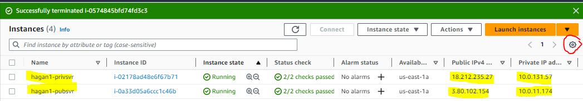
9. Select the public server and click the **Connect** button.
10. On the next screen, click **Connect**. Another tab should open and connect to this instance.
11. **Paste the following screenshot in the Word doc as Screenshot2.**   
    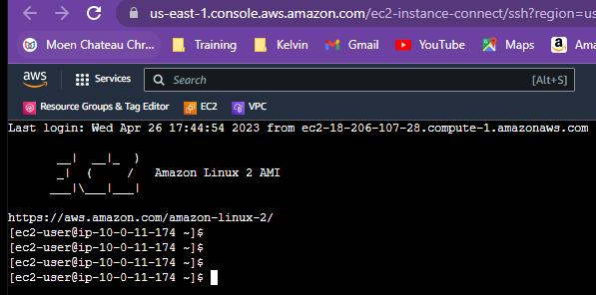
12. Go back to the AWS Console browser tab, and check the private server checkbox. (Uncheck the public server if nec.)
13. Scroll up top and click the **Connect** button.
14. On the next screen, click **Connect**. Another tab should open and attempt to connect to this instance. **Does it work**?
15. Go back to the AWS Console browser tab, and with the private server checkbox check, go to the **Details** tab and obtain the **Private IPv4 Address**.
16. Go to the public server browser tab and type **ping *privsvr* *IP address***. After a few ping replies, hit **Ctrl-c** to stop the pings. (**Note**: If you can’t type anything in this tab, the connection might have timed out. Close the tab and repeat the steps to connect to the public server)
17. If you can’t ping, troubleshoot.
18. **Paste the following screenshot as Screenshot3 into the yourlastname-AWS_VPC.docx and save it.**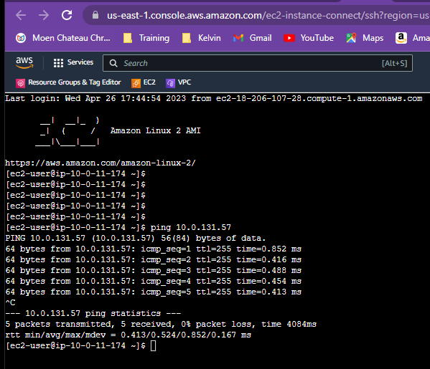
19. **Upload Word doc to blackboard.**

**Remove everything from AWS (Clean up)**

When you're finished you can remove/delete all of the AWS resources created in the lab to avoid incurring any unnecessary costs.

This includes VPC and Terminate the 2 EC2 instances.